Poker game

**What is it?**

Simple iOS and OSX applications, developed for my master’s project in the University of Kent. I used a TCP/IP protocol to allow players to play online. Both applications use the language Swift.

**How to install?**

1. Please, download the zip file which contain the full project. In this zip file, you will find 2 repositories, one is the server, and the other one is the client. Copy the 2 repositories on your computer.
2. If your computer doesn’t have the IDE Xcode, please, download it from the App Store.
3. When the 2 first steps are done, open each repository and open the file ‘xcodeproj’.
4. The project will be open in a new Xcode window.

**How to launch?**

***Server:***

1. When the project is open, on the top of the window 2 buttons (play and stop), and next to them a selected scheme and a device (see figure 1). Click on the device / simulator.
2. When your Mac is selected click on the button ‘play’.



Figure 1. Start server

***Client:***

This section will be a bit more technical. First of all, a command line tool is required to launch multiple simulator. We will install the application on multiple devices before to launch the game.

1. Exactly like the server, select a device and launch the application. At this moment, the application will be installed on the simulator. (figure 2)
2. To have a better experience, I suggest you to use a recent simulator with a good resolution (iPhone 6 plus, iPhone 6s plus, iPad air 2).

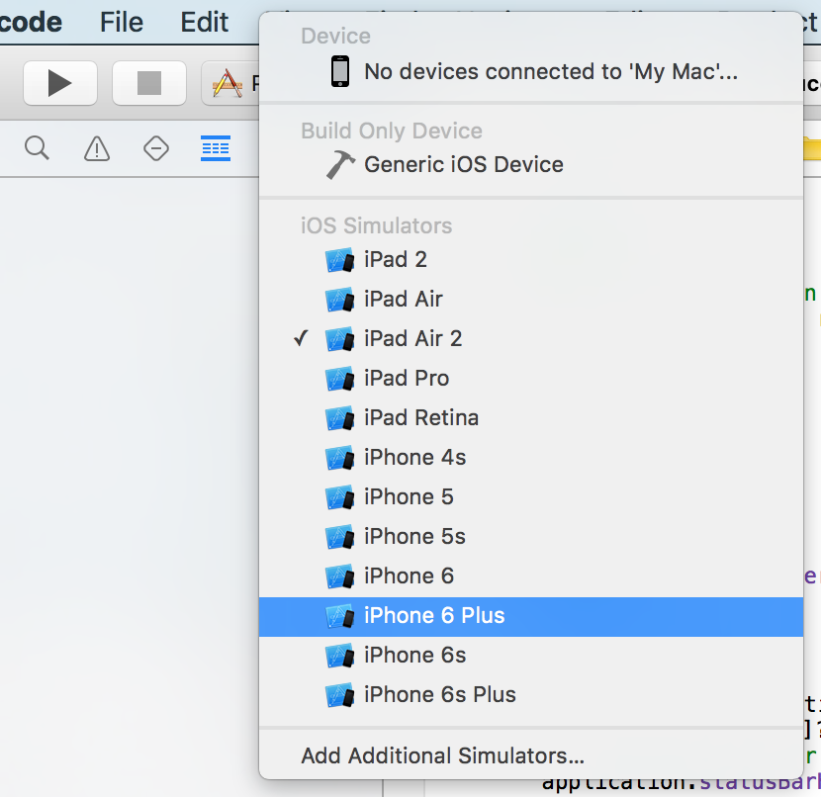

Figure 2. Select a device

When the application is installed on all devices you want, we can start to launch multiple simulator. You can launch a simulator from Xcode, in that case, you will see all the debug logs of the project. In addition of a simulator, it’s possible to start simultaneously a real device by plugging it on Xcode and selecting it from the list in figure 2.

1. Normally, your computer has a command tool line already installed, launch this application.
2. When the tool is opened, use these command lines:

cd;

cd /Applications/Xcode.app/Contents/Developer/Applications;

open -n Simulator.app

1. These command lines open a new simulator.
2. When the new simulator is open, please select one of the device your installed the poker application (see figure 3).

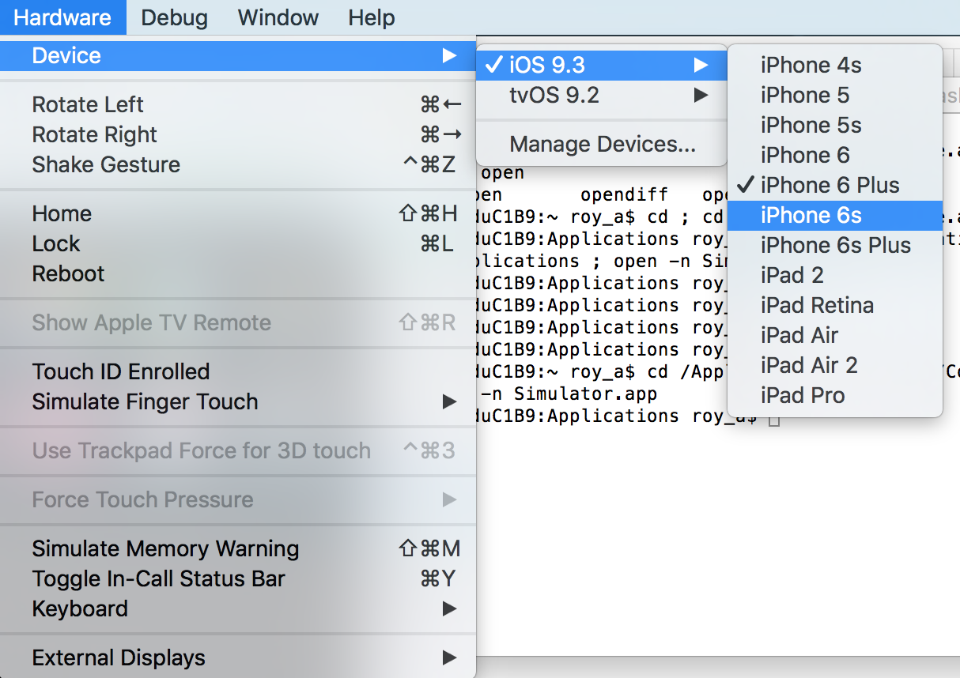

Figure 3. Modify the simulator

1. When all the simulators you want are open, find the application on the board and click on it to launch the application. (see figure 4)
2. 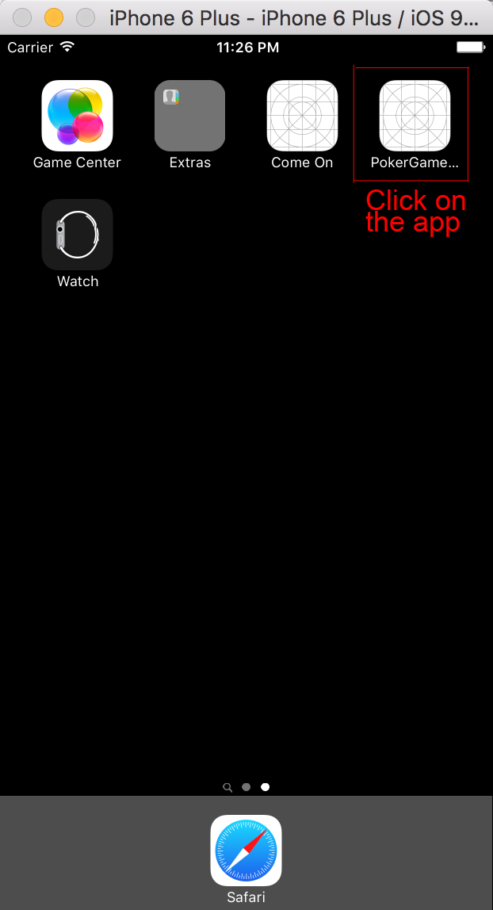 The game is ready to be used.

Figure 4. Application poker